Grade 4 Supply List
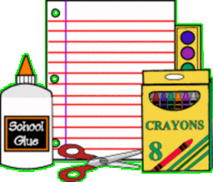
- Total of 8 composition notebooks (2 for Science/6 for ELA)
- 2 Graphing/Quad notebooks (Math)
- 8 two pocket folders
- 4 packs of # 2 pencils
- 2 blue pens (Math)
- 1 plastic ruler and 1 protractor
- 4 packs of sticky notes
- 1 bottle of Elmer’s glue
- 1 pack of wide ruled loose-leaf paper
- 2 packs of 500 count white copy paper
- 1 pack of Crayola markers and crayons
- 2 glue sticks
- 1 package of construction paper
- 2 boxes of tissues
- 2 rolls of paper towels
- 1 bottle of hand sanitizer
- 1 box of gallon size Ziploc bags
- 1 container of Clorox wipes (Math)

